Acadgild – Big Data Hadoop & Spark
Project 2
Music Data Analysis (By Nihit Rai)
A leading music-catering company is planning to analyse large amount of data received from
varieties of sources, namely mobile app and website to track the behaviour of users, classify users,
calculate royalties associated with the song and make appropriate business strategies. The file server
receives data files periodically after every 3 hours.
Fields present in the data files
Data files contain below fields.
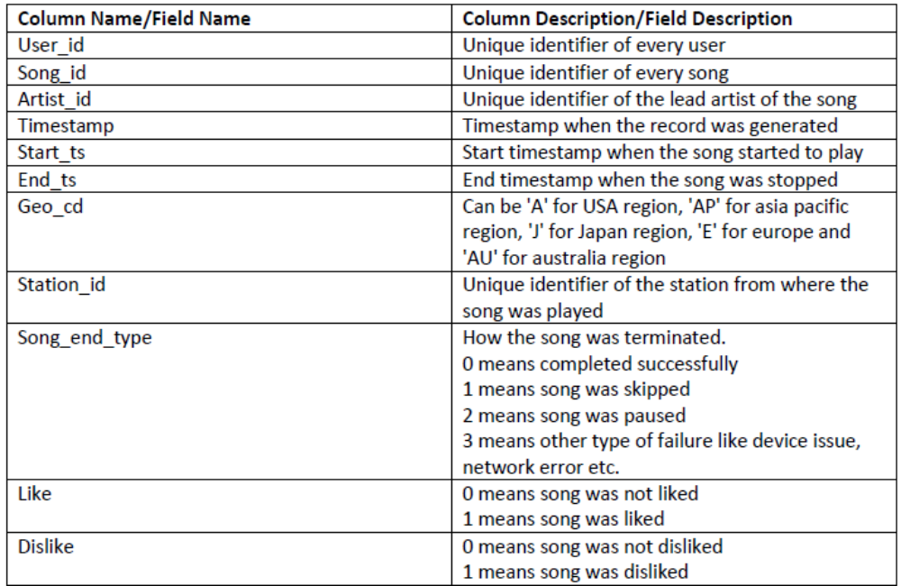
LookUp Tables
There are some existing look up tables present in NoSQL databases. They play an important role in
data enrichment and analysis.
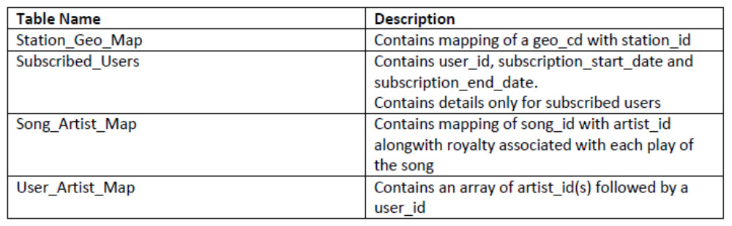
DATASET:
1. Data coming from web applications reside in /data/web and has xml format.
2. Data coming from mobile applications reside in /data/mob and has csv format.
3. Data present in lookup directory should be used in HBase.

Below is the link for same.
https://drive.google.com/drive/folders/0B_P3pWagdIrrMjJGVlNsSUEtbG8?usp=sharing
Mobile data - 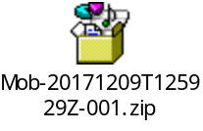 Web data - 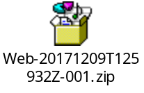
Lookup file data - 
Data Enrichment
Rules for data enrichment

- If any of like or dislike is NULL or absent, consider it as 0.
- If fields like Geo_cd and Artist_id are NULL or absent, consult the lookup tables for fields Station_id and Song_id respectively to get the values of Geo_cd and Artist_id.
- If corresponding lookup entry is not found, consider that record to be invalid.

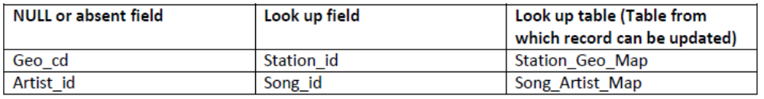
Data Analysis (SHOULD BE IMPLEMETED IN SPARK)
It is not only the data which is important, rather it is the insight it can be used to generate
important. Once we have made the data ready for analysis, we have to perform below analysis on a
daily basis.

- Determine top 10 station_id(s) where maximum number of songs were played, which were liked by unique users.
- Determine total duration of songs played by each type of user, where type of user can be 'subscribed' or 'unsubscribed'. An unsubscribed user is the one whose record is either not present in Subscribed_users lookup table or has subscription_end_date earlier than the timestamp of the song played by him.
- Determine top 10 connected artists. Connected artists are those whose songs are most listened by the unique users who follow them.
- Determine top 10 songs who have generated the maximum revenue. Royalty applies to a song only if it was liked or was completed successfully or both.
- Determine top 10 unsubscribed users who listened to the songs for the longest duration.

Challenges and Optimisations:
- LookUp tables are in NoSQL databases. Integrate them with the actual data flow.
- Try to make joins as less expensive as possible.
- Data Cleaning, Validation, Enrichment, Analysis and Post Analysis have to be automated. Try using schedulers.
- Appropriate logs have to maintained to track the behaviour and overcome failures in the pipeline.
Flow of operations
A schematic flow of operations is shown below.

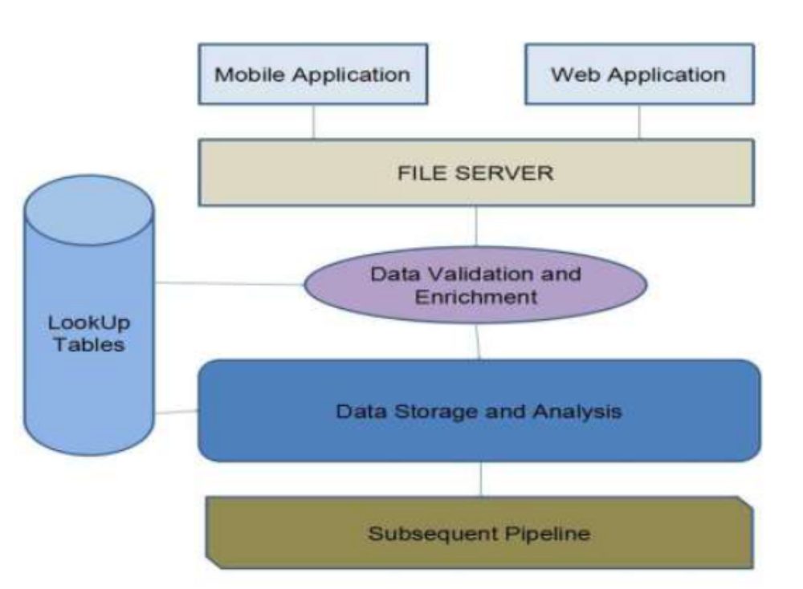

Solution

Project zip - 

Extract this in directory /home/acacgild/
Path in scripts have to be changed if you wish to extract the same in any other directory

Spark project for data analysis - 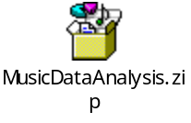 Scala class - 
Runnable Jar for spark project - 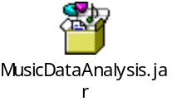

Folder architecture

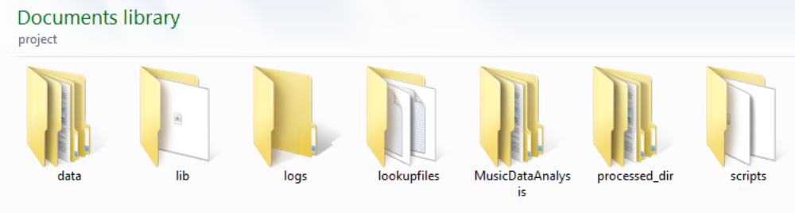

- Data – Has subfolders to keep web and mobile data



- Lib – Contains piggyback.jar used in dataformatting

- Logs – Contains files
  - current-batch.txt - to track batch ID.
  - Project logs

- Lookupfiles – Contains files to load in lookup tables

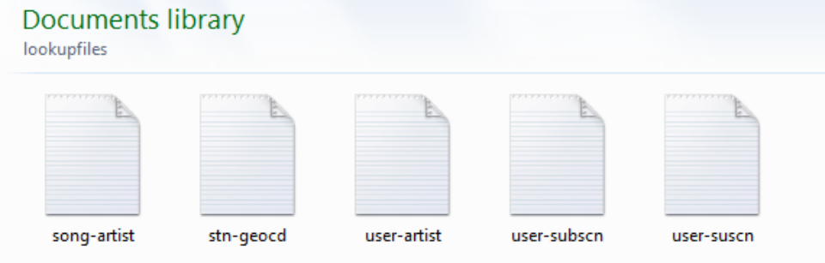

- MusicDataAnalysis – Spark project for data analysis



- processed_dir – Contains sub-directories to store valid and invalid files



- scripts – Contains all scripts and runnable jar for analysing data using spark
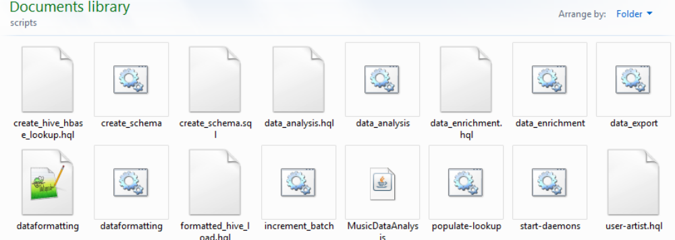
Step by step execution of Solution

Step 1 – Starting MySQL

Commands –
# sudo service sshd start
# sudo service mysqld start

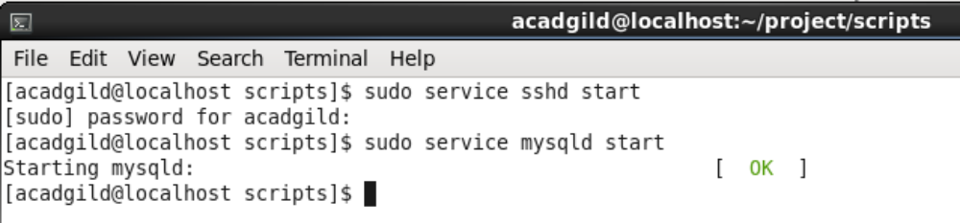

Step 2 – Placing web and mobile input files in appropriate directory for processing

Web - /home/acadgild/project/data/web
Filename – file.xml

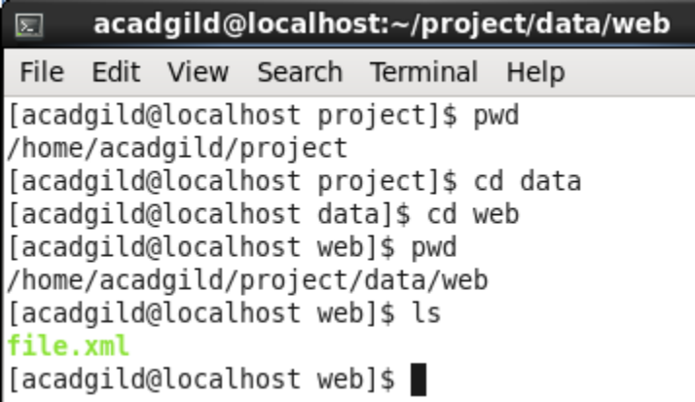

Mobile – /home/acadgild/project/data/mob
Filename – file.txt

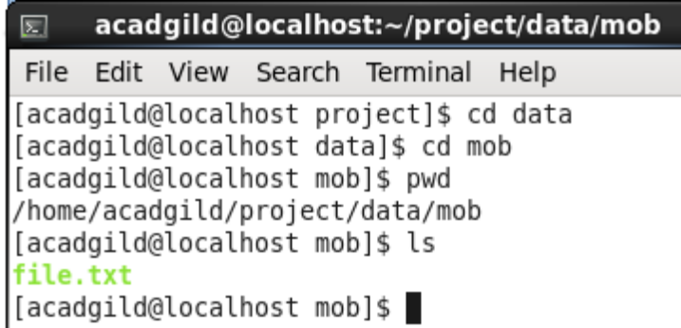

Step 3 – Starting all daemons and initializing the logs

Script to run - /home/acadgild/project/scripts/start-daemons.sh

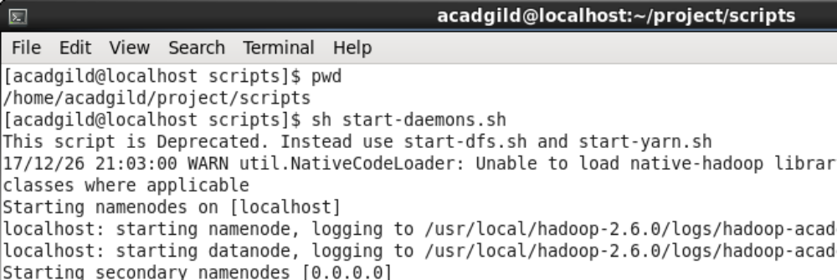

Step 4 - Populating HBase lookup tables

Script to run - /home/acadgild/project/scripts/populate-lookup.sh

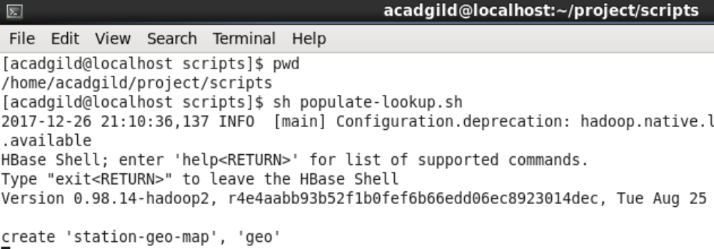

Step 6 – Creating database ‘Musicdata’ in hive

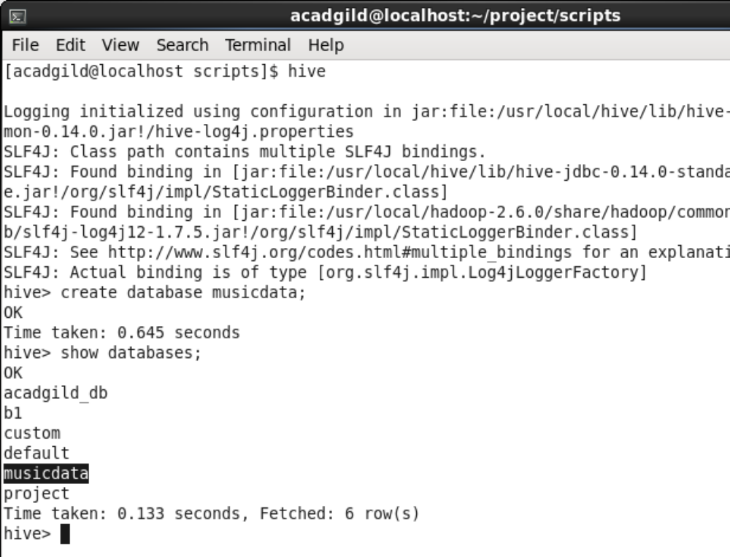

Step 6 – Data formatting using pig and loading data in hive tables

Script to run - /home/acadgild/project/scripts/dataformatting.sh

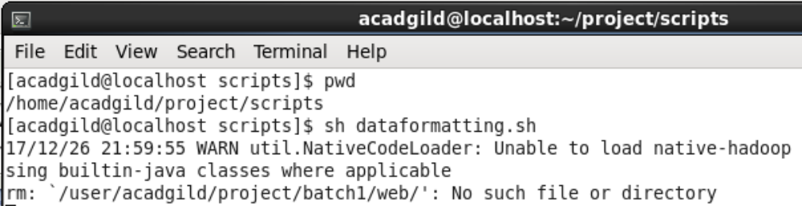

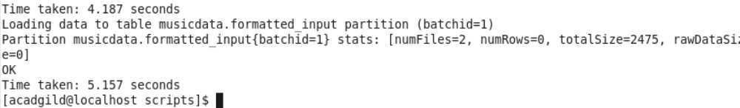

Checking hive table

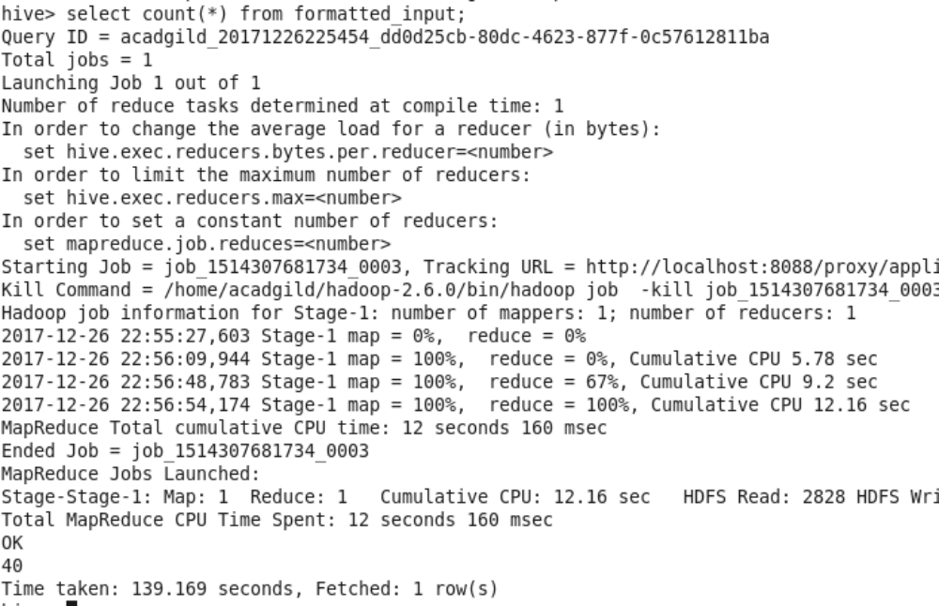

Step 7 – Creating hive external tables linked to hbase lookup tables. These hive tables would be used later as lookup tables.

Script to run - /home/acadgild/project/scripts/create_hive_hbase_lookup.hql

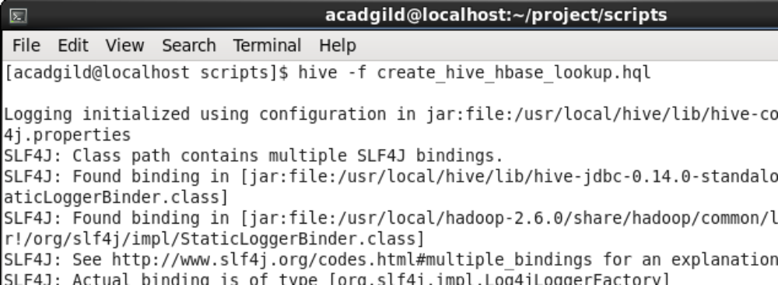

Step 8 – Data enrichment using data in hive table formatted_input and look up tables

Script to run - /home/acadgild/project/scripts/data_enrichment.sh

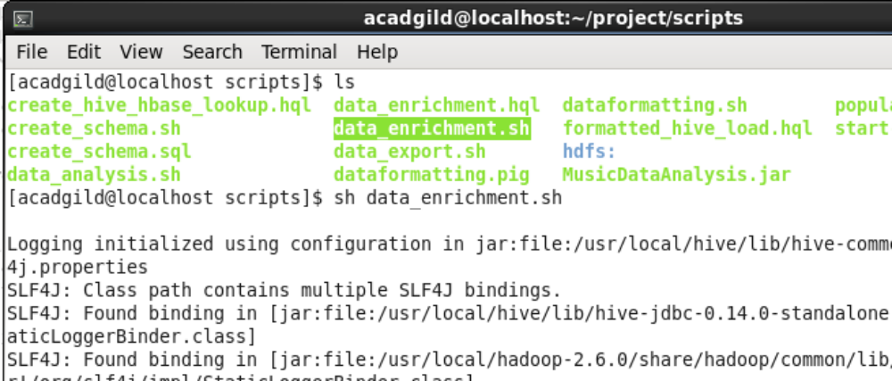
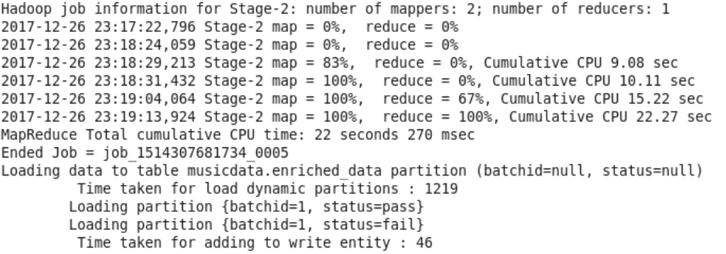

Checking enriched_data table in hive to confirm

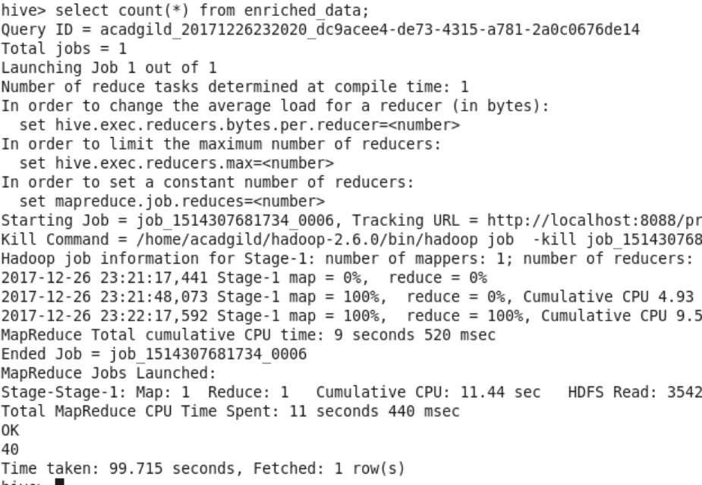

Upon checking we could see that 40 rows have been inserted in hive table enriched_data.

Step 9 – Data analysis and export to HIVE

Spark jar to run for data analysis – MusicDataAnalysis.jar

Script to run to begin data analysis and export to hive - /home/acadgild/project/scripts/data_analysis.sh

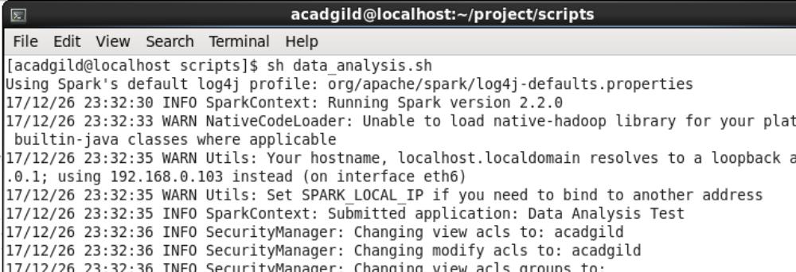

Checking hive tables to confirm data analysis

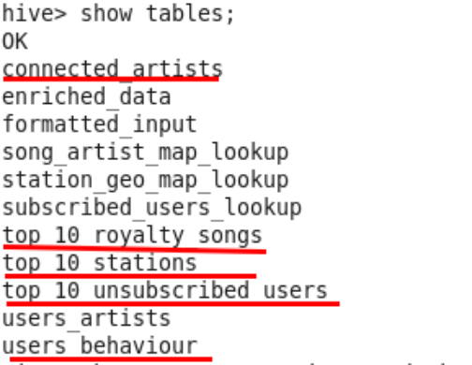

- Top 10 connected artists

(Requirement: Determine top 10 connected artists. Connected artists are those whose songs are most listened by the unique users who follow them.)

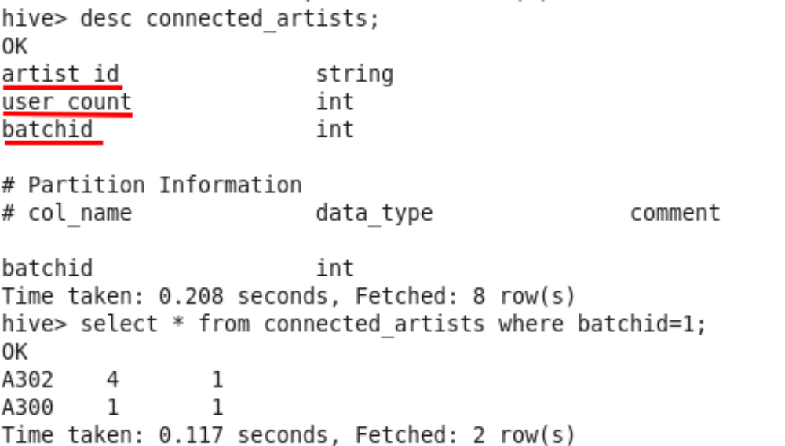

- Top 10 stations

(Requirement: Determine top 10 station_id(s) where maximum number of songs were played, which were liked by unique users.)

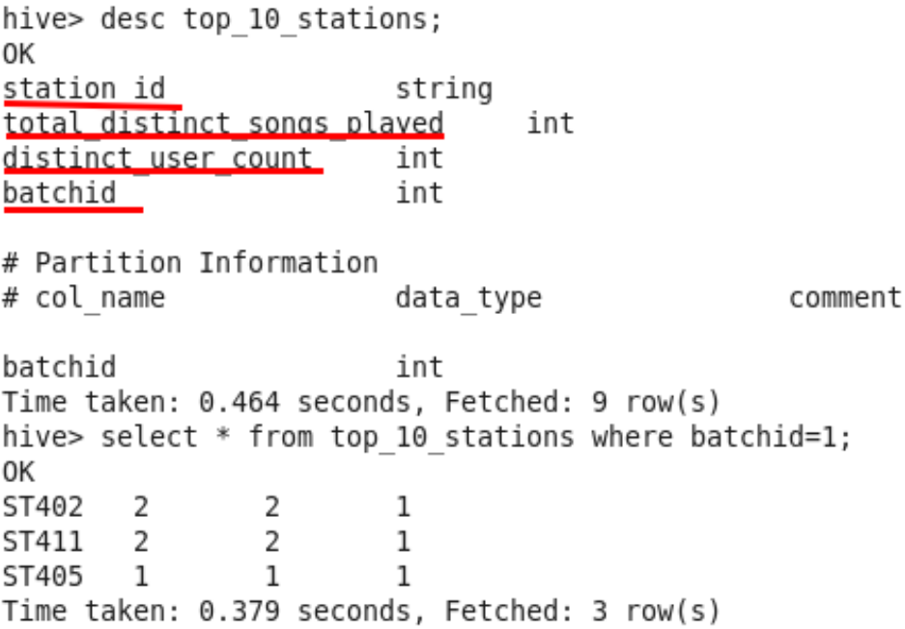

- User behaviour –

(Requirement: Determine total duration of songs played by each type of user, where type of user can be 'subscribed' or 'unsubscribed'. An unsubscribed user is the one whose record is either not present in Subscribed_users lookup table or has subscription_end_date earlier than the timestamp of the song played by him.)

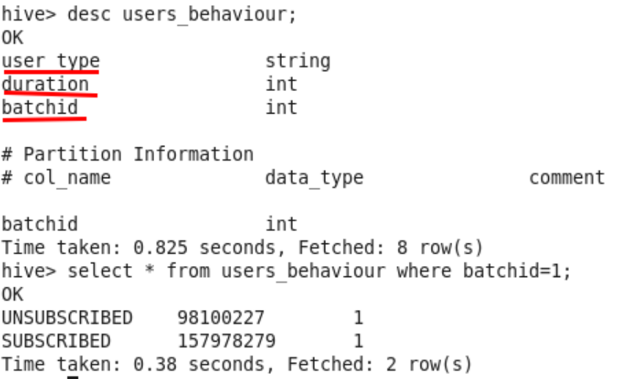

- Top 10 unsubscribed users

(Requirement: Determine top 10 unsubscribed users who listened to the songs for the longest duration.)

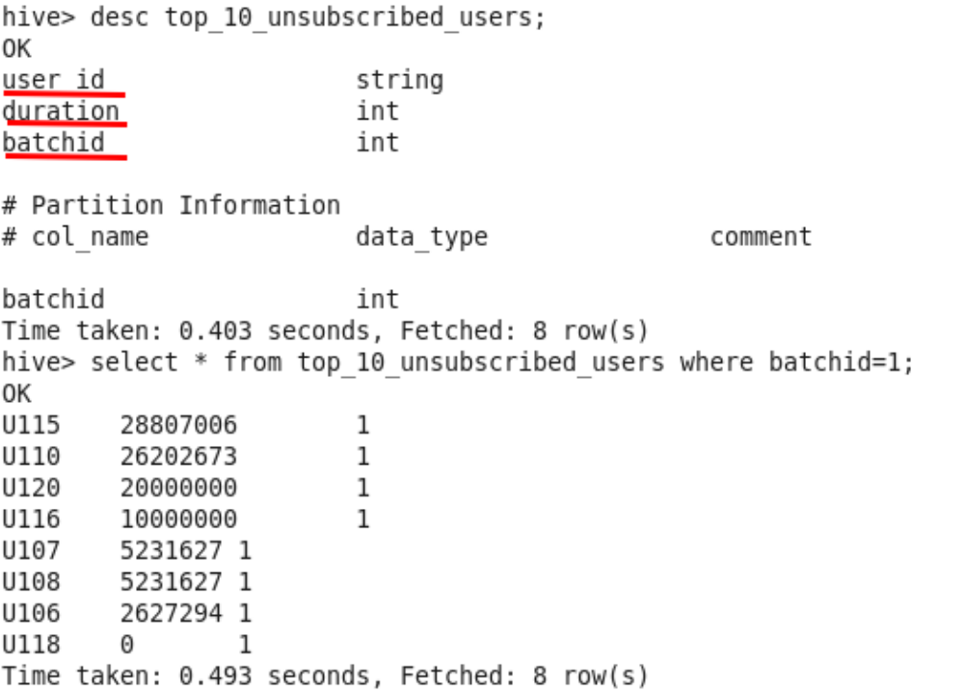

- Top 10 royalty songs

(Requirement: Determine top 10 songs who have generated the maximum revenue. Royalty applies to a song only if it was liked or was completed successfully or both.)

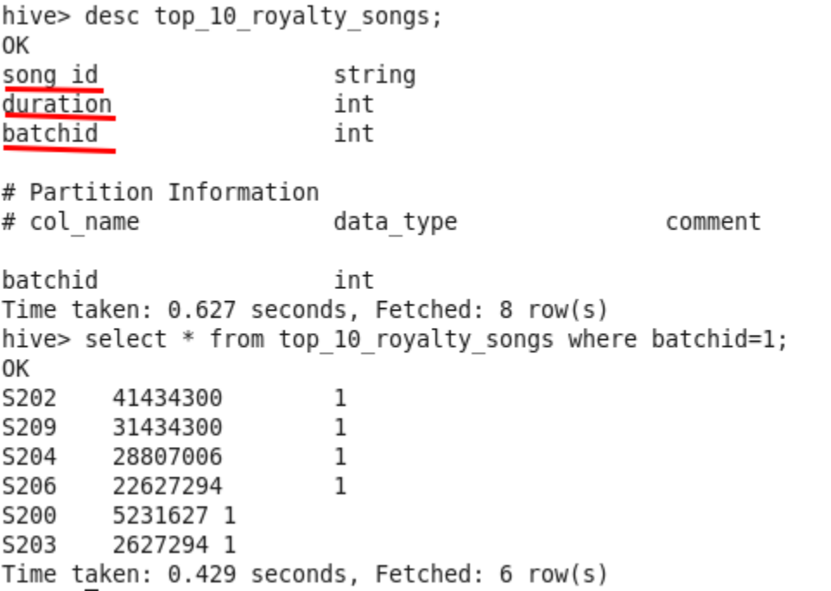

Now that data has been successfully stored in Hive, it could be exported to MySQL using sqoop

Step 10 – Create MySQL schema to store exported data

Script to run - /home/acadgild/project/scripts/create_schema.sh
Internally called SQL script - /home/acadgild/project/scripts/create_schema.sql

Step 11 – Calling sqoop scripts to export tables one by one

Commands –

To get batch ID - batchid=`cat /home/acadgild/project/logs/current-batch.txt`

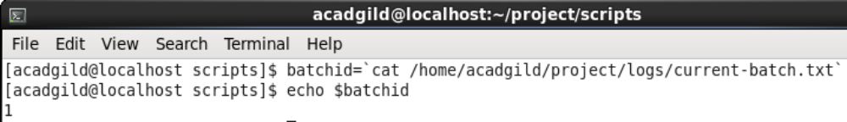

- Exporting top_10_stations
Command -
sqoop export \
--connect jdbc:mysql://localhost/musicdata \
--username 'root' \
--table top_10_stations \
--export-dir hdfs://localhost:9000/user/hive/warehouse/musicdata.db/top_10_stations/batchid=$batchid \
--input-fields-terminated-by ',' \
-m 1
- Exporting users_behaviour

Command –
sqoop export \
--connect jdbc:mysql://localhost/musicdata \
--username 'root' \
--table users_behaviour \
--export-dir hdfs://localhost:9000/user/hive/warehouse/musicdata.db/users_behaviour/batchid=$batchid \
--input-fields-terminated-by ',' \
-m 1

- Exporting connected_artists

Command - sqoop export \
--connect jdbc:mysql://localhost/musicdata \
--username 'root' \
--table connected_artists \
--export-dir hdfs://localhost:9000/user/hive/warehouse/musicdata.db/connected_artists/batchid=$batchid \
--input-fields-terminated-by ',' \
-m 1

- Exporting top_10_royalty_songs

Command - sqoop export \
--connect jdbc:mysql://localhost/musicdata \
--username 'root' \
--table top_10_royalty_songs \
--export-dir hdfs://localhost:9000/user/hive/warehouse/musicdata.db/top_10_royalty_songs/batchid=$batchid \
--input-fields-terminated-by ',' \
-m 1

- Exporting top_10_unsubscribed_users

Command - sqoop export \
--connect jdbc:mysql://localhost/musicdata \
--username 'root' \
--table top_10_unsubscribed_users \
--export-dir hdfs://localhost:9000/user/hive/warehouse/musicdata.db/top_10_unsubscribed_users/batchid=$batchid \
--input-fields-terminated-by ',' \
-m 1

Checking musicdata database in MySQL
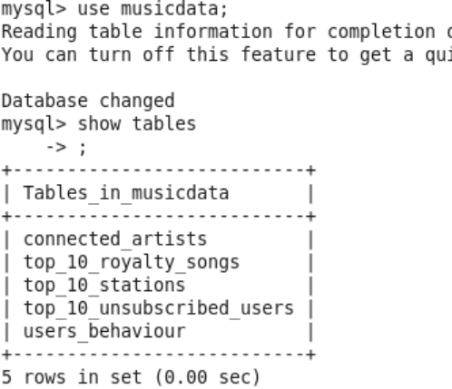
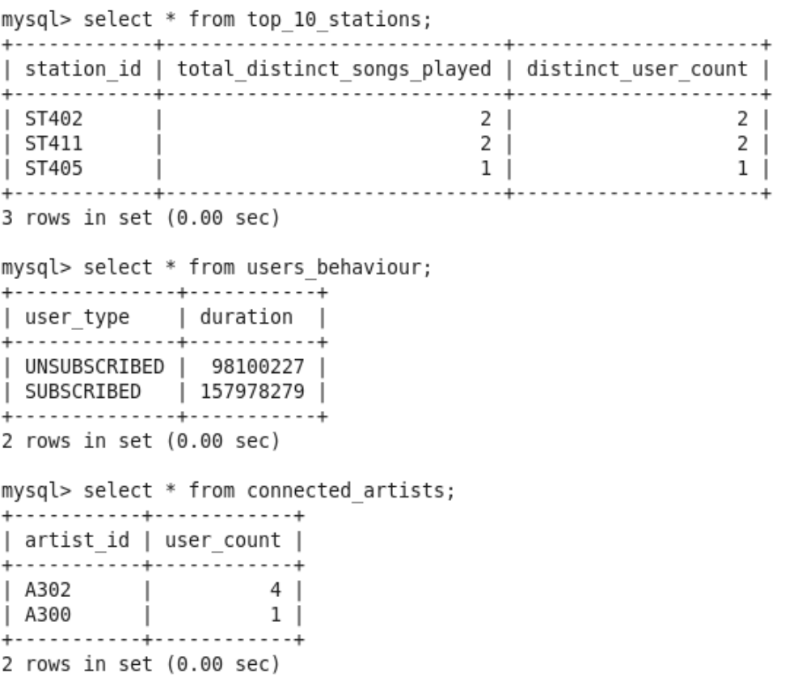

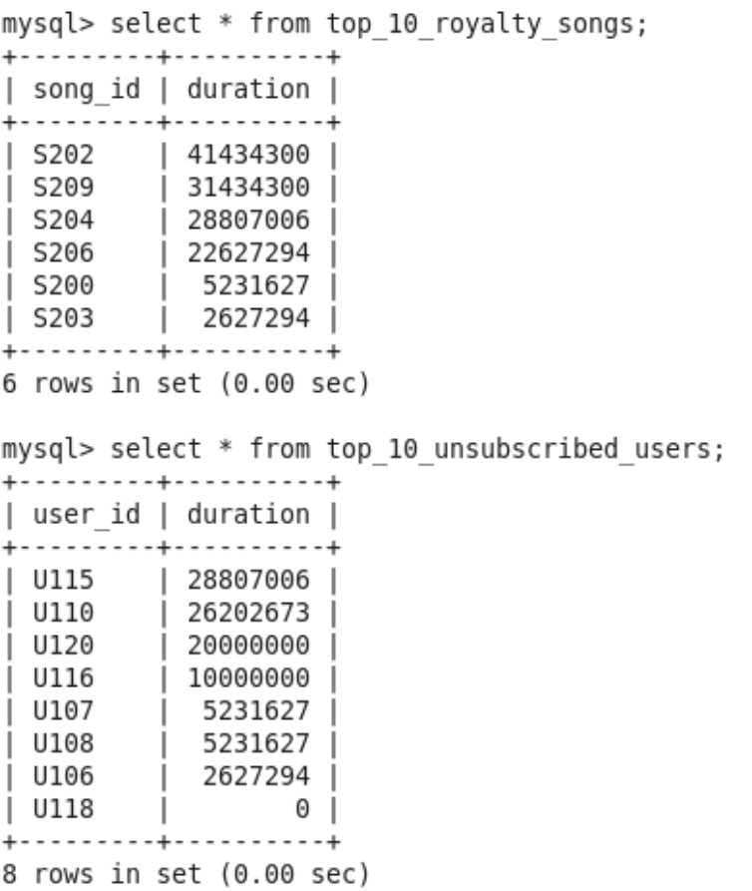

Hence we have confirmed that data pertaining to all the requirements have been exported to MySQL.
Now we can increment the batched for further files to process.

Commands to increment batch ID :-

batchid=`cat /home/acadgild/project/logs/current-batch.txt`
LOGFILE=/home/acadgild/project/logs/log_batch_$batchid
echo "Incrementing batchid..." >> $LOGFILE
inc=`expr $batchid + 1`
echo -n $inc > /home/acadgild/project/logs/current-batch.txt

Script to run - /home/acadgild/project/scripts/increment_batch.sh

